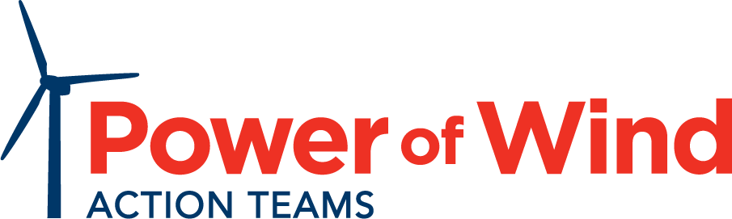
American Wind Energy Pledge
- Wind energy is now one of the most affordable options for generating electricity in America.
- The wind industry has created over 100,000 U.S. jobs and, with policies currently in place, will create 50,000 more jobs from 2017 to 2020, including 8,000 more factory jobs.
- U.S. wind projects have invested over $143 billion in private capital in rural communities and infrastructure over the last decade, and from 2017 to 2020 will create $85 billion in economic activity.
- America generates enough electricity from wind to power 25 million average homes.
- Energy independence and energy security are in every American’s best interests.
I pledge to my constituents that I will: ONE, support adding more affordable and reliable renewable energy such as wind power to the grid; and TWO, oppose any effort to inhibit the reasonable growth of wind energy, considering its many benefits.

Signature

Printed name

Title, City/State/District

Date

Please return this signed form to:
Power of Wind, 1501 M St. NW, Suite 900, Washington D.C., 20005 or scan and email to info@powerofwind.org

